Nathan Donaldson/U0632803

Lab 3 – Timers

1. Using a timer clock source of 8 MHz, calculate PSC and ARR values to get a 60 Hz interrupt.
   * PSC = 11
   * ARR = 1,333
2. Look through the Table 13 "STM32F072x8/xB pin definitions" in the chip datasheet and list all pins that can have the timer 3 capture/compare channel 1 alternate function.
   * PE3 AF0
   * PA6 AF1
   * PC6 AF0
   * PB4 AF1
3. List your measured value of the timer UEV interrupt period from first experiment.
   * .38125 ms
4. Describe what happened to the measured duty-cycle as the CCRx value increased in PWM mode 1.
   * It increased
5. Describe what happened to the measured duty-cycle as the CCRx value increased in PWM mode 2.
   * It decreased
6. Include a logic analyzer screenshot of one PWM capture. (doesn't matter which)
   * 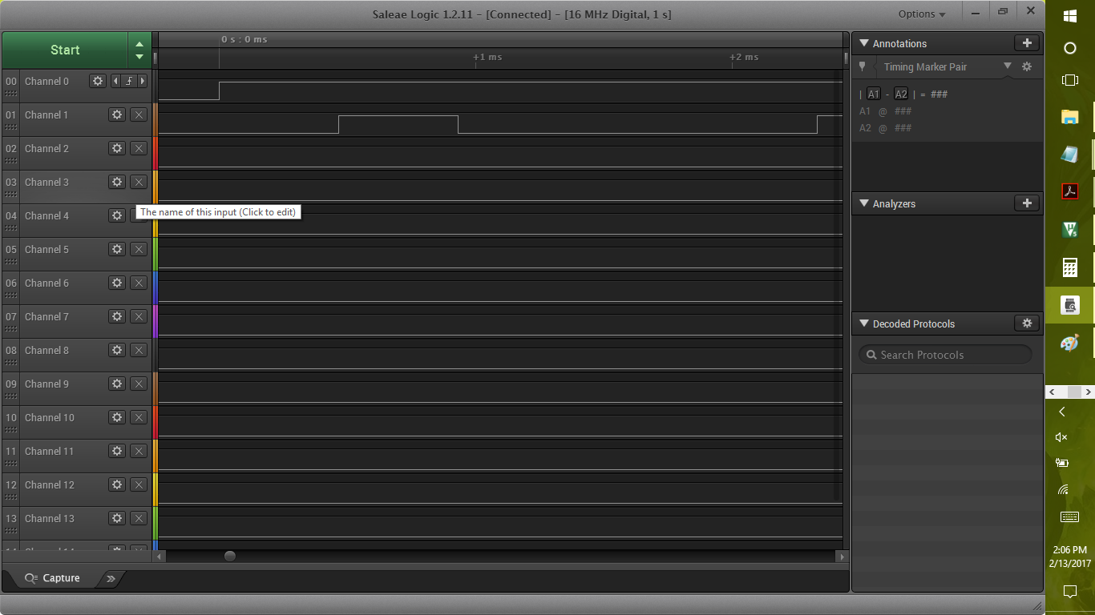
7. What PWM mode is shown in figure 4.6 of the lab manual? (PWM mode 1 or 2)
   * PWM mode 1